1. **What is Digital Assets?**

Digital assets includes Image, Video, PDF, Layout (.indd files), Audio, Edam, Document.

Limit for any asset is 3GB. Document is 2 types. 1. Reference Data, 2. Presentations

Reference Data includes word and excel files.

Digital Assets are mainly used by Business Team.60-70% of content come from eDAM.

1. **API has services**, currently we don’t have rest API services

<https://helpx.adobe.com/experience-manager/6-4/sites/developing/using/clientlibs.html>

1. **How does the Create, Search, Upload and Download Assets work?**

Name for each of the file assets can be searched based on the index.

Delete can be done by Authors and Admins only.

Development environment is having authorization access.

Production environment is not having authorization access.

After Uploading Asset we can capture metadata and we can search each of them based on their indexes.

Each of the uploaded image has the 3-4 sizes created automatically.

Thumbnails 48-48, 140-200, 319-319 standard format given by business.

1. **Workflow in AEM**?

Create the renditions.

Process the Metadata (Read all the properties and save in the JCR (Java Content Repository)

eDAM URL: <https://edam.dev.capitalgroup.com/libs/cq/workflow/content/console.html>

eDAM Architecture: <https://confluence.capgroup.com/display/NGM/EDAM+-+AWS+Architecture>

eDAM Workflow

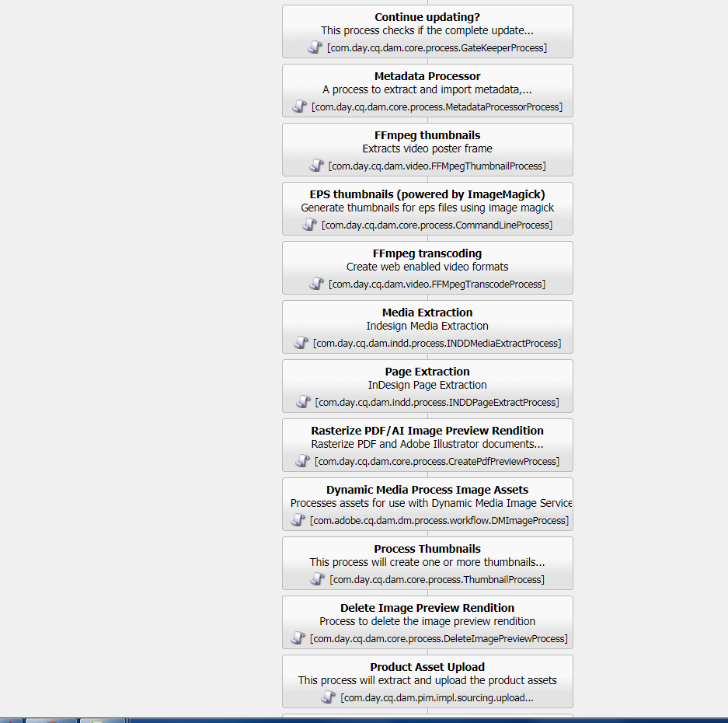

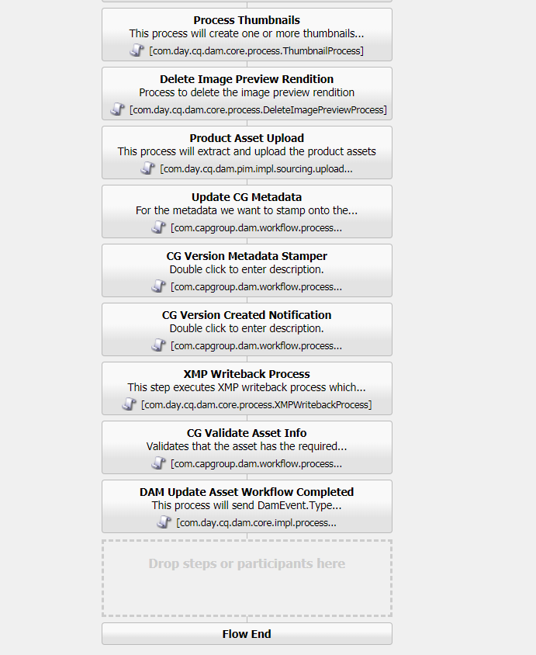

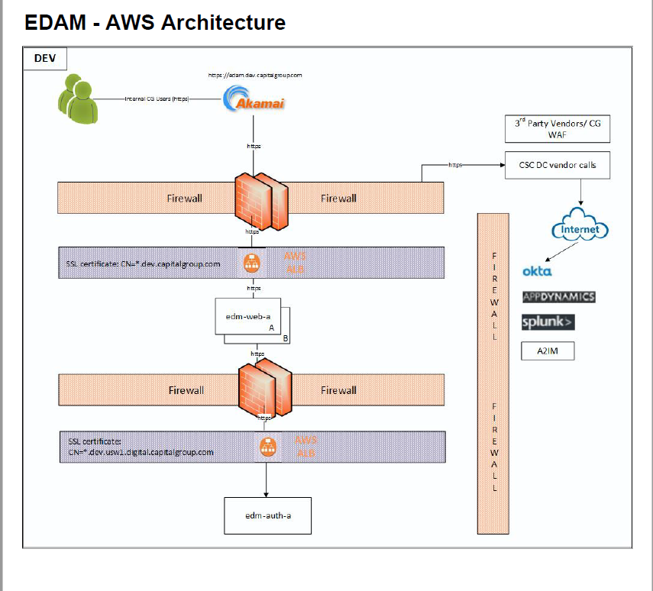

EDAM AWS Architecture:

1. Internal CG Users
2. Dev URL: https://edam.dev.capitalgroup.com-->Akamai (redirecting, load balancing, caching)
3. Firewall
4. 3rd Party Vendors/CG WAF—Web Application Firewall(we are setting the AKAMAI)
5. CSC is a server, CSC DC Vendor calls hits the AWS Server
6. Okta –Authentication
7. App Dynamics(Check the health), Splunk(Check logs) and A2IM(edam to A2IM)
8. SSL Certificate is Web Server(Apache)
9. Firewall is CG Proxy Firewall
10. SSL Certificate is Dispatcher Layer
11. Edam-auth-a( AEM Server Authorization is done)